**AGRICULTURE LOAN MANAGEMENT SYSTEM**

Use case diagram:

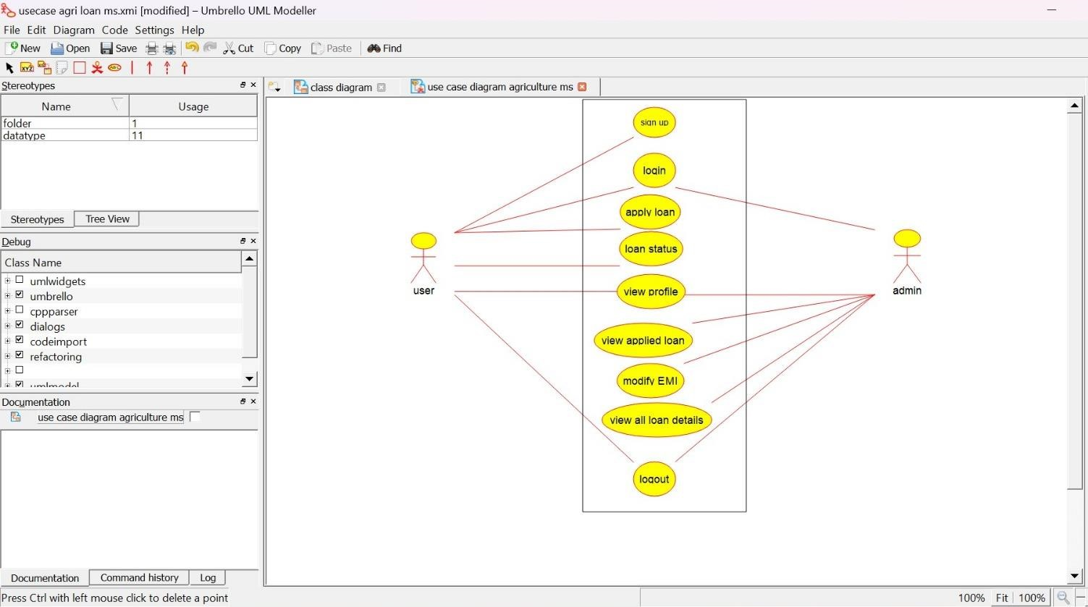

Class diagram:

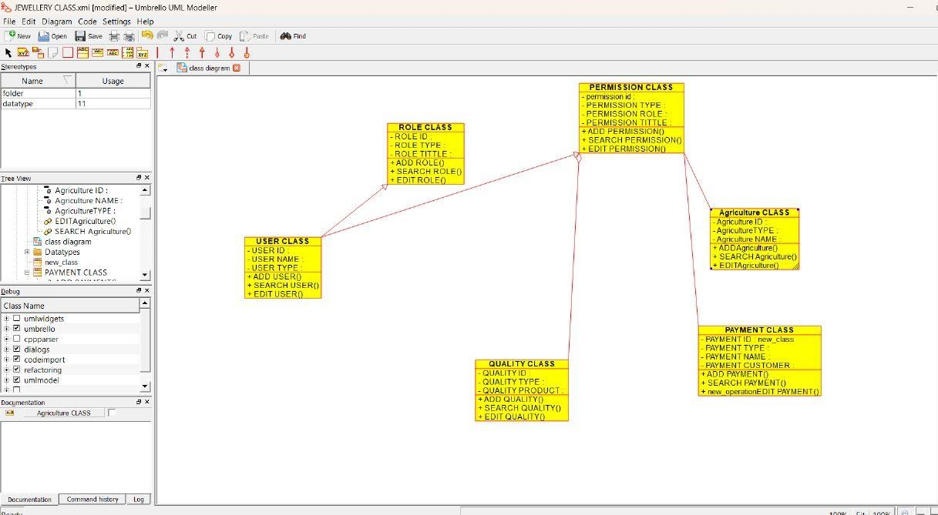

Activity diagram:

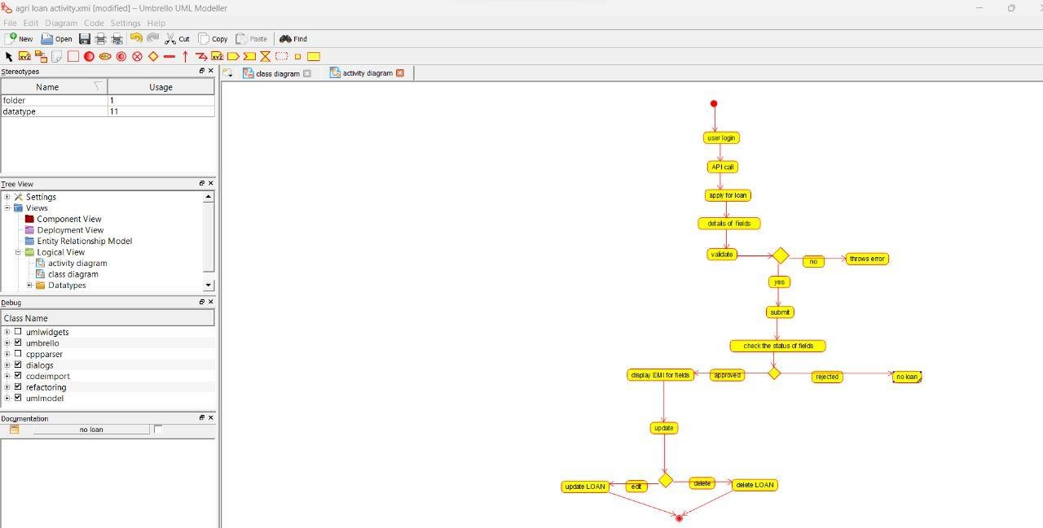

Sequence diagram:

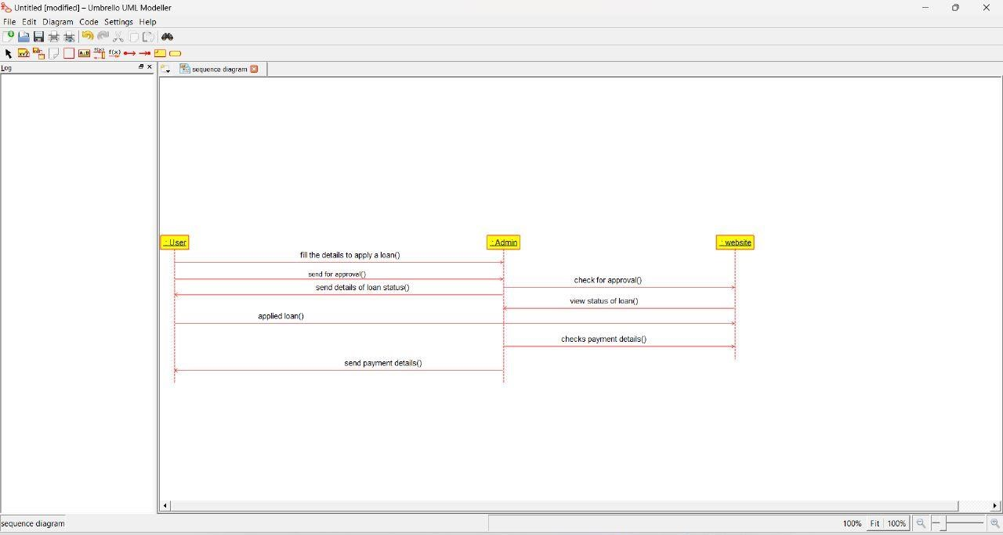

**JEWEL LOAN MANAGEMENT SYSTEM**

USE CASE DIAGRAM:

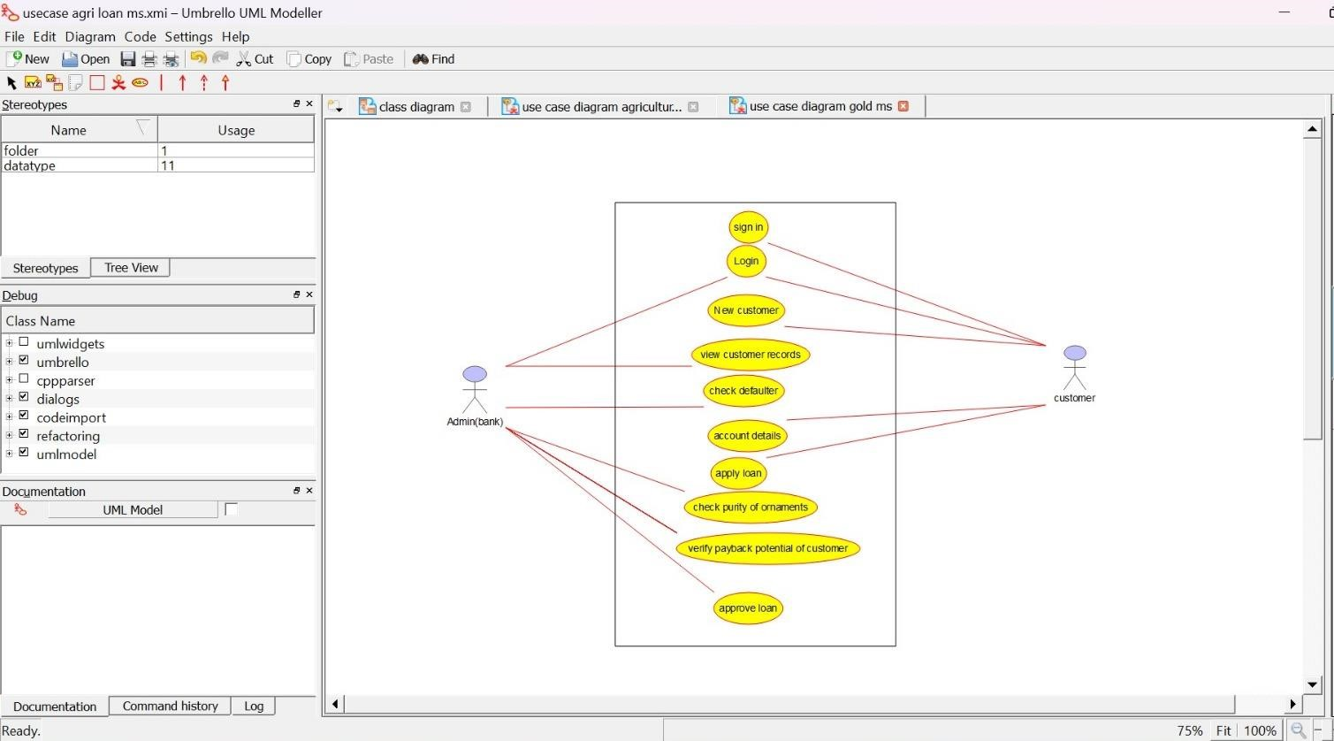

CLASS DIAGRAM:

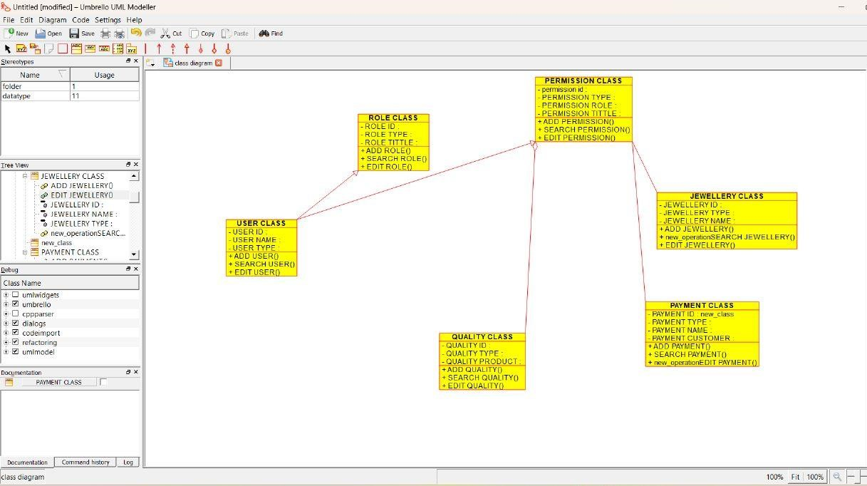

ACTIVITY DIAGRAM:

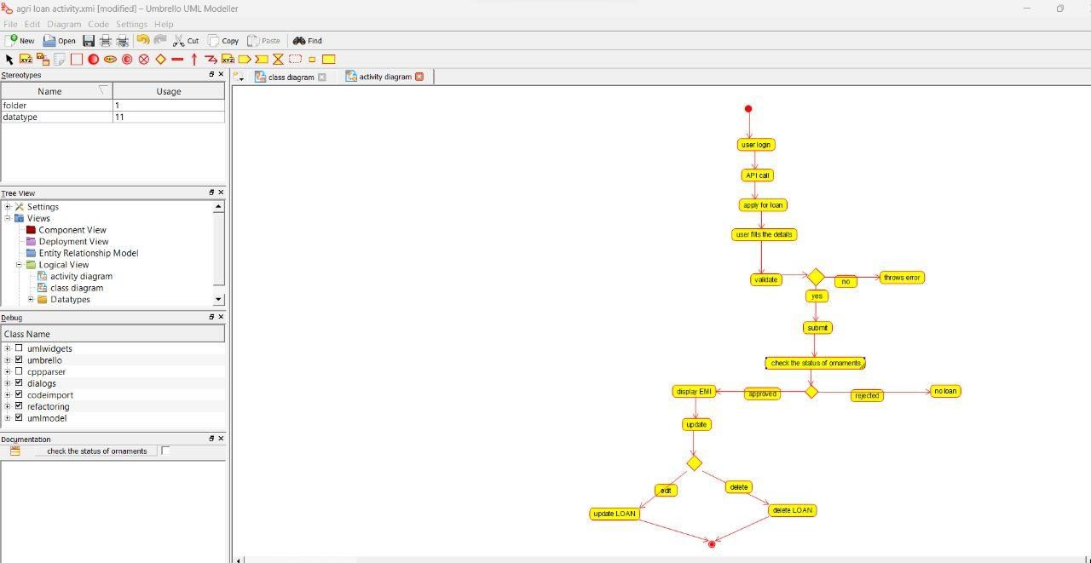

SEQUENCE DIAGRAM:

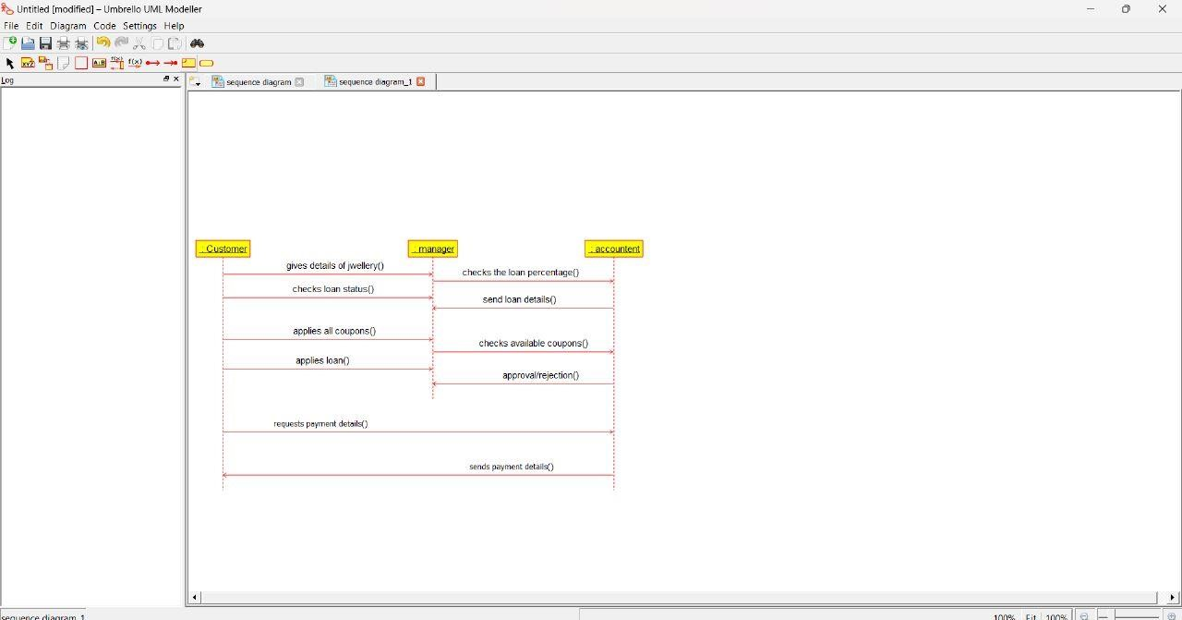

**PERSONAL LOAN MANAGEMENT SYSTEM** USE CASE DIAGRAM:

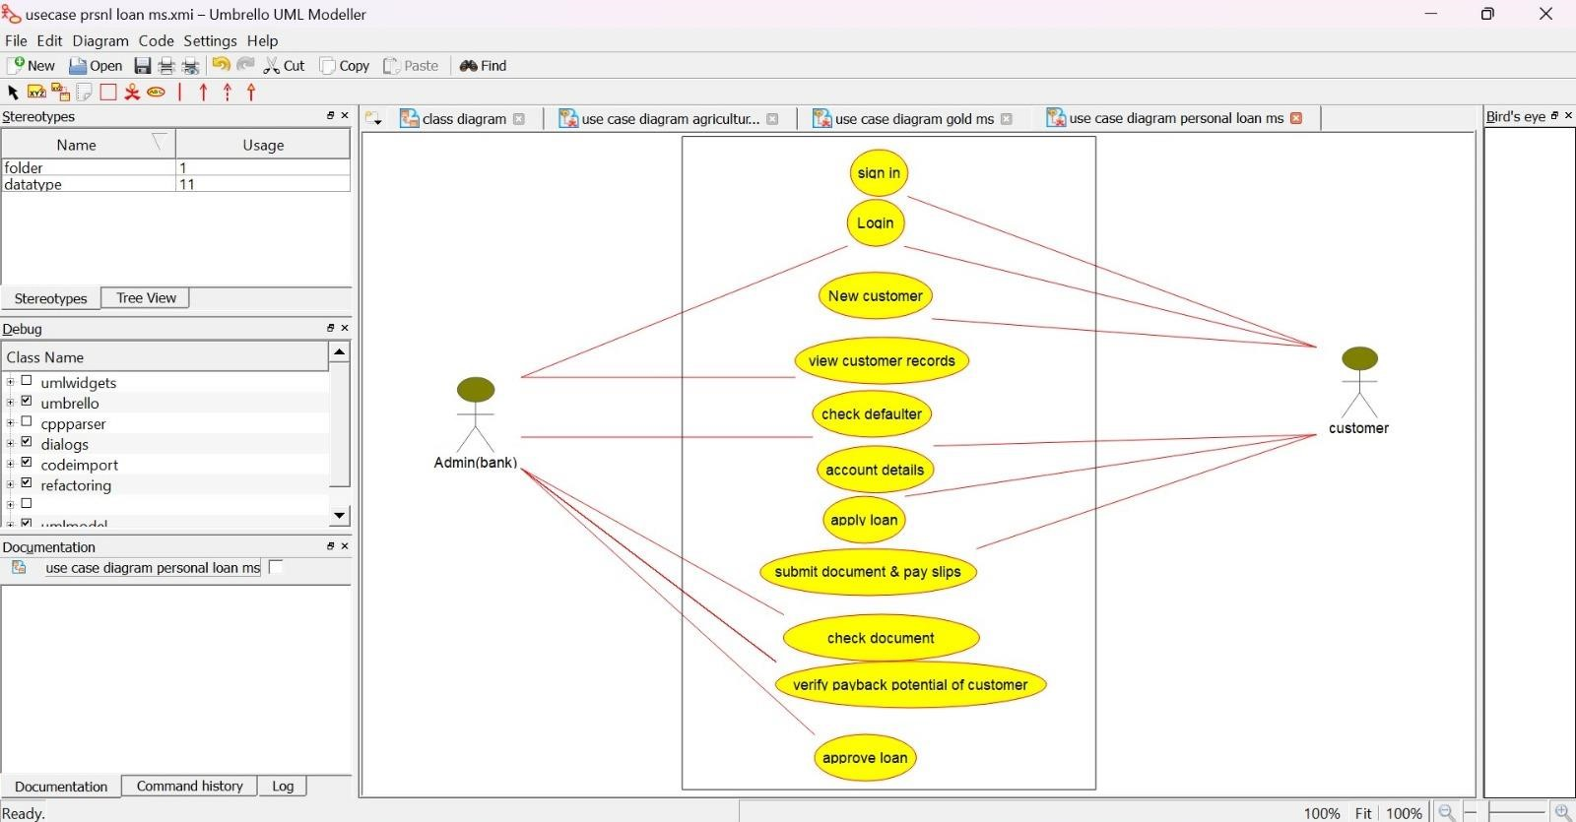

CLASS DIAGRAM:

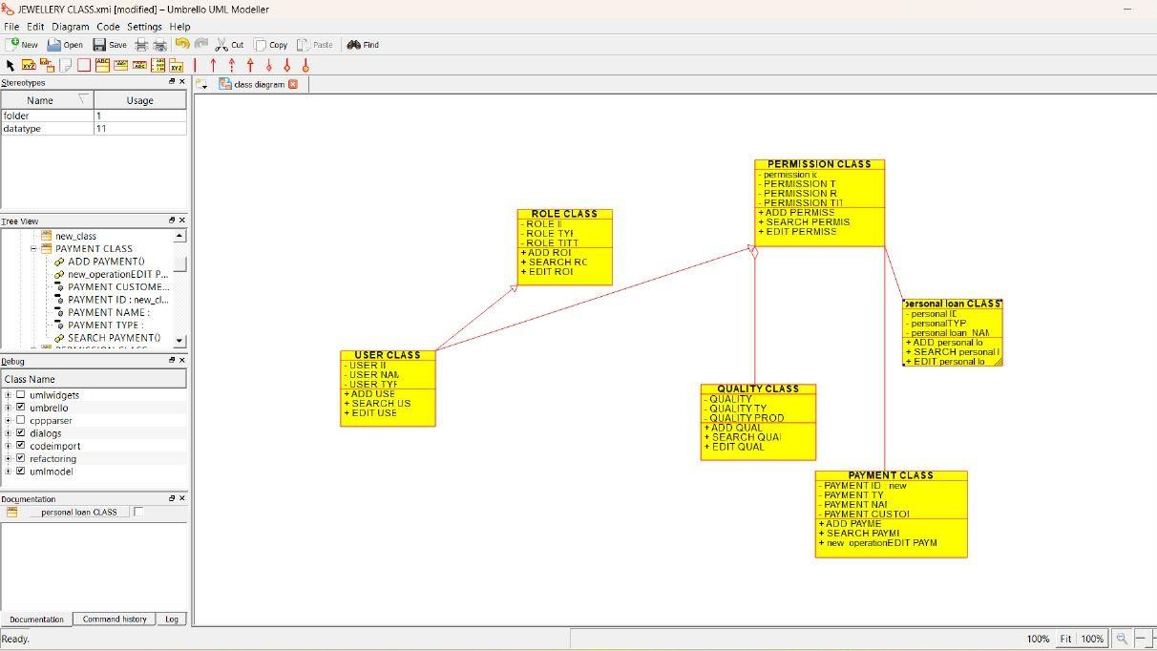

ACTIVITY DIAGRAM:

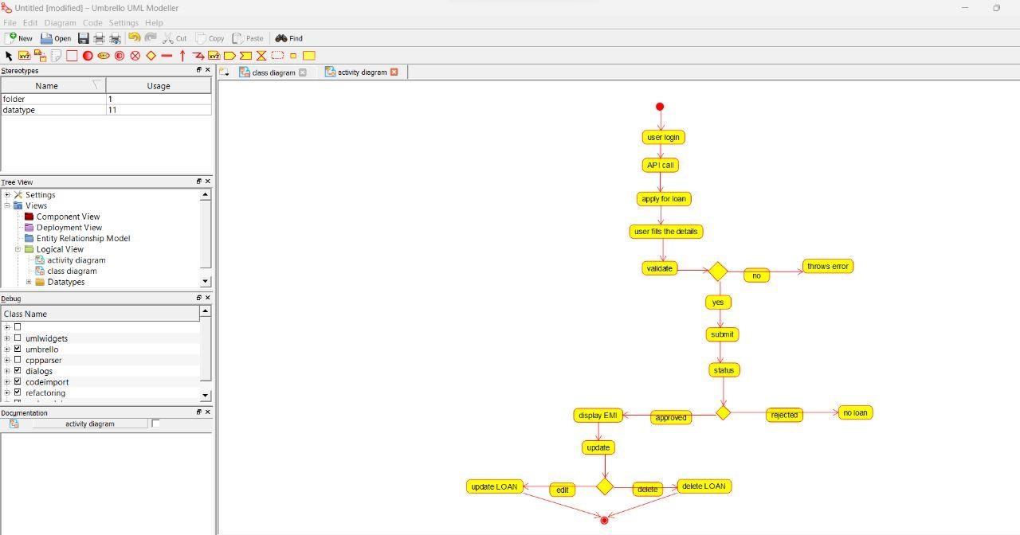

SEQUENCE DIAGRAM:

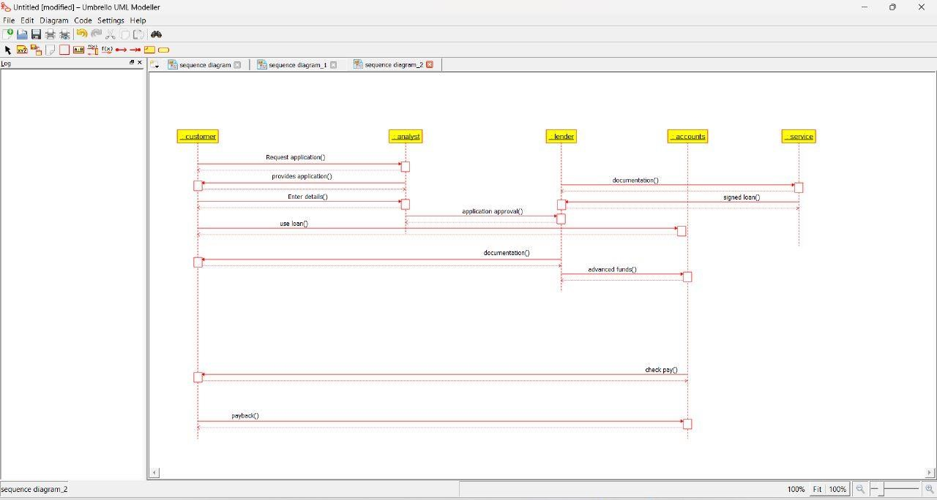

**HOME LOAN MANAGEMENT SYSTEM**

USE CASE DIAGRAM:

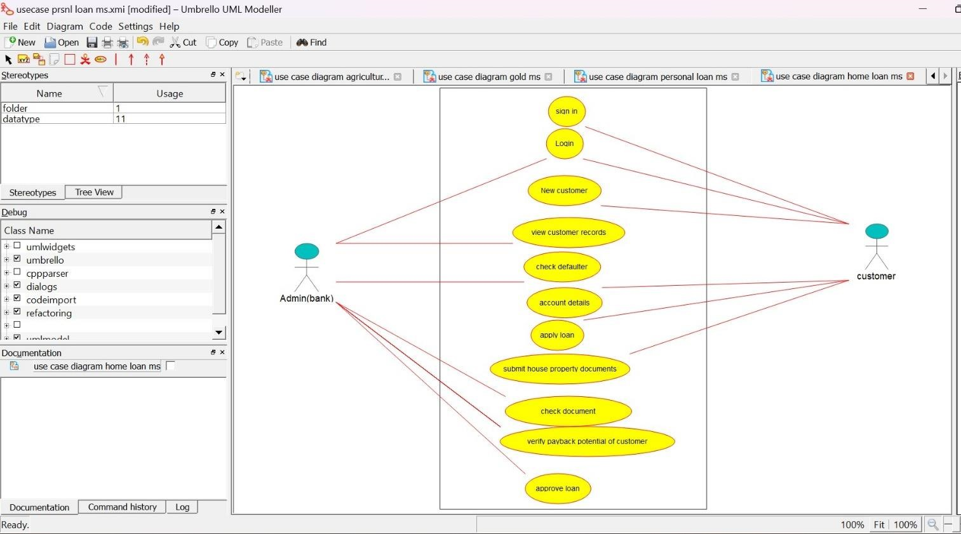

CLASS DIAGRAM:

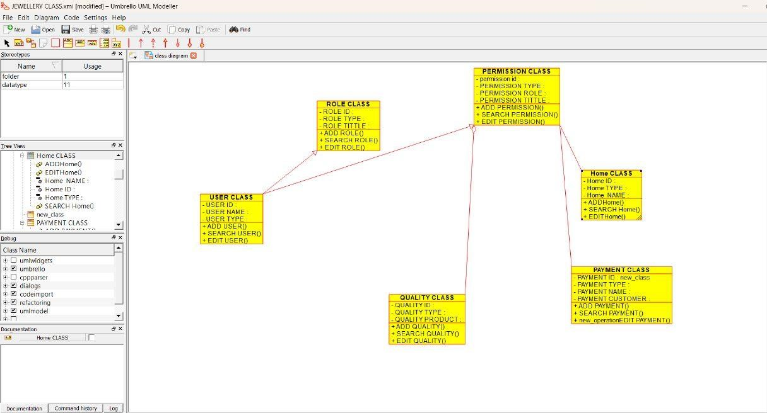

ACTIVITY DIAGRAM:

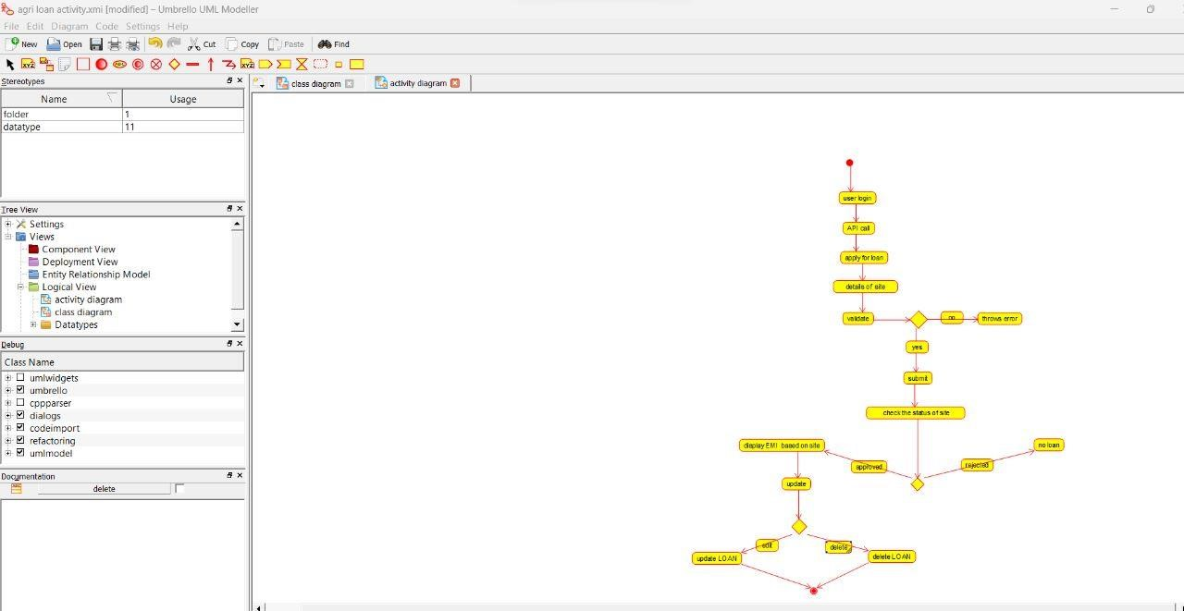

SEQUENCE DIAGRAM:

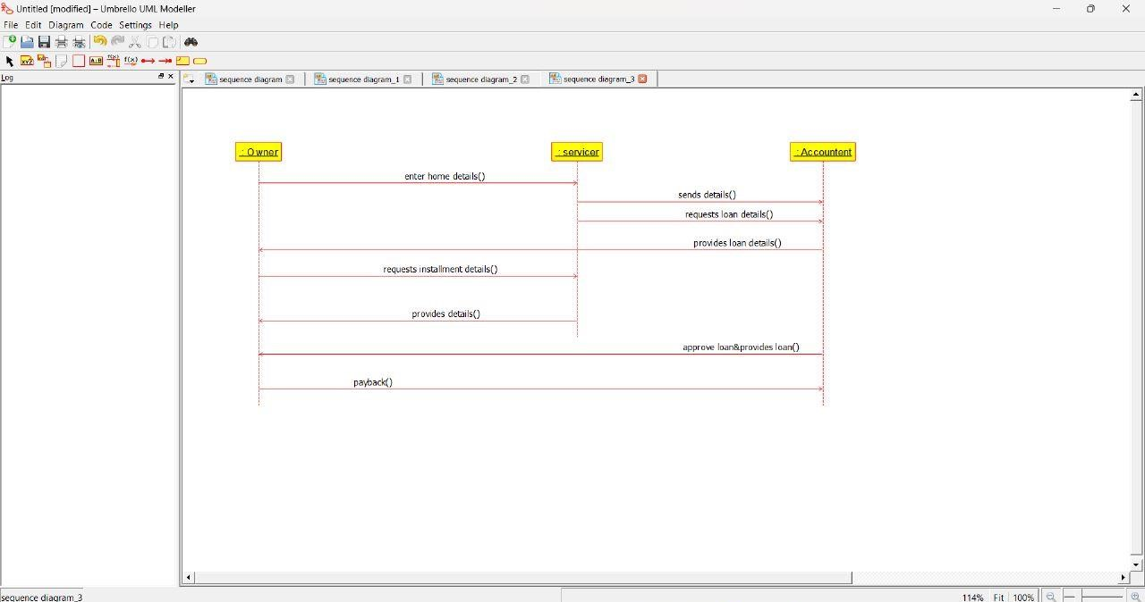

**LAND REGISTRATION SYSTEM**

USE CASE DIAGRAM:

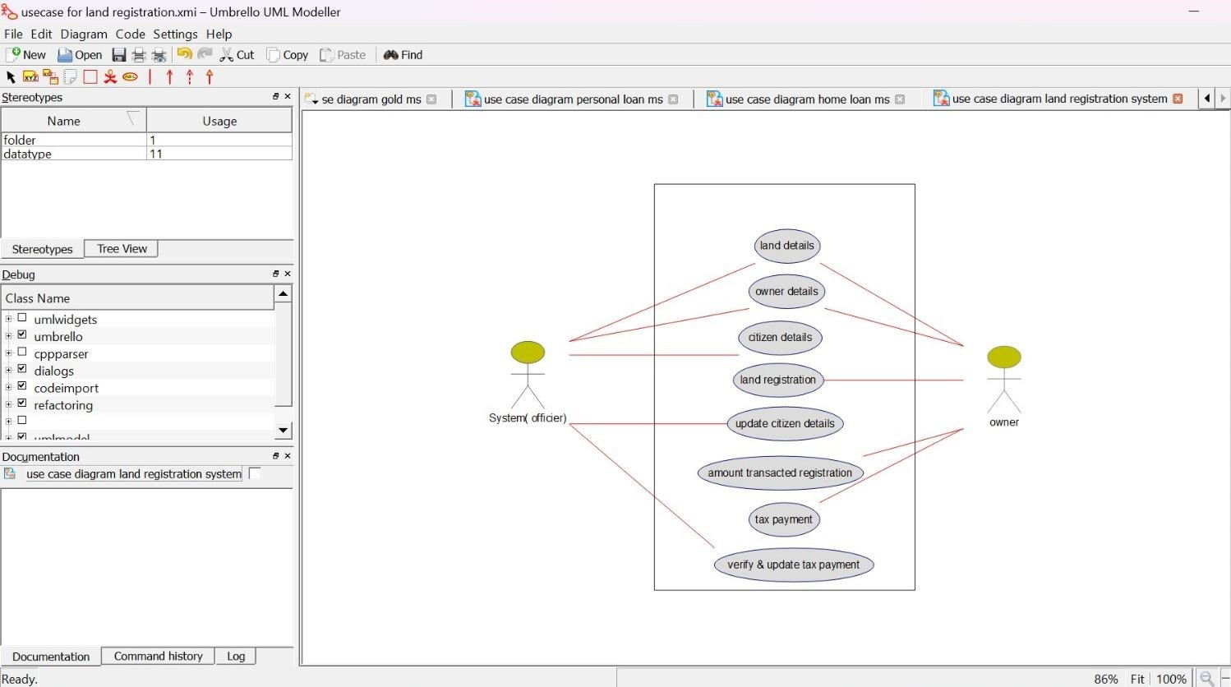

CLASS DIAGRAM:

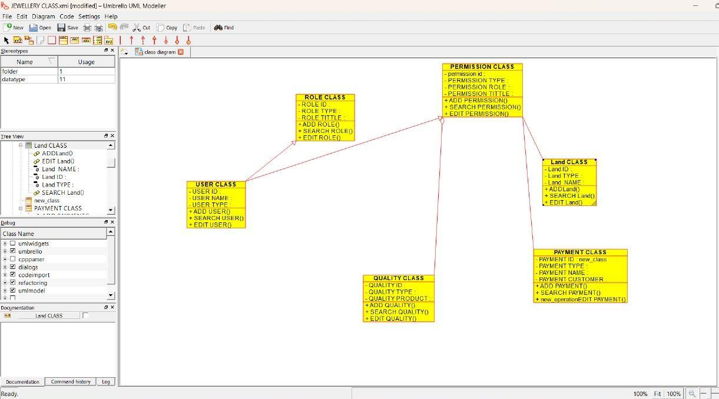

ACTIVITY DIAGRAM:

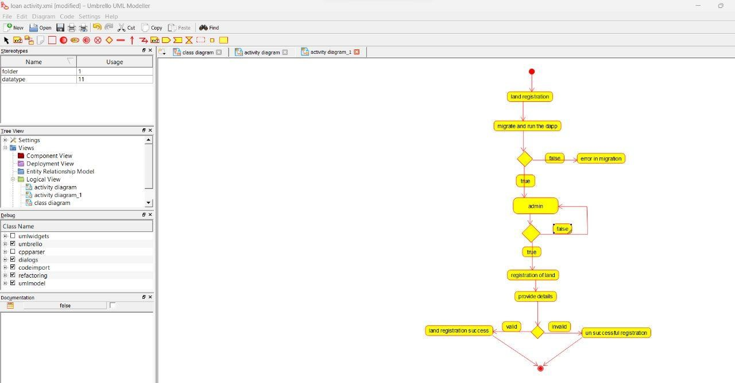

SEQUENCE DIAGRAM:

